**Azure Boards**

With Azure Boards, you can quickly and easily start tracking tasks, features, and bugs associated with your project. You do this by adding one of three work item types—**epics, issues,** and **tasks**—that the Basic process provides. As works progresses from not started to completed, you update the State workflow field from **To Do**, **Doing**, and **Done**.

| **Work item types** | **Workflow** |
| --- | --- |
| Basic process work item types, conceptual image | Basic process workflow, conceptual image |

When you add an issue, task, or epic, you create a work item. Each work item represents an object stored in the work item data store. Each work item is assigned an identifier. The IDs are unique within your projects.

* Add **epics** to track significant features or requirements.
* Use **issues** to track user stories, bugs, or other smaller items of work.
* Use **tasks** to track even smaller amounts of work for which you want to track time either in hours or days.

**Work Item Form:**

Each work item supports tracking data contained in work item fields. Also, it captures changes as updates are made within the History field and comments made in the Discussion section.

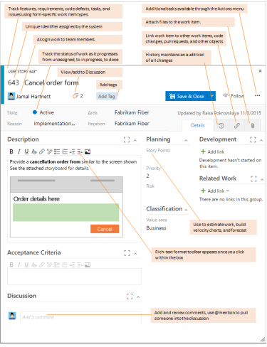

**Track work, implement Kanban:**

* Quickly add and update the status of work you track from **New**, **Active**, **Resolved**, and **Closed** using the Kanban board. Add tasks as child items to user stories.
* Assign work to team members, tag with labels to support queries and filtering, or share information through descriptions, attachments, or links to network shared content.
* Prioritize work through drag-and-drop on your team backlog.

**Update the status of issues:**

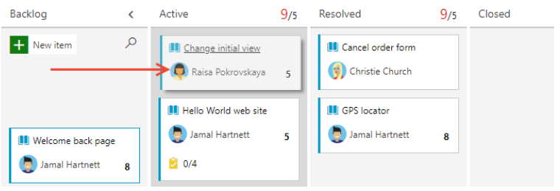

**Prioritize your backlog of issues:**

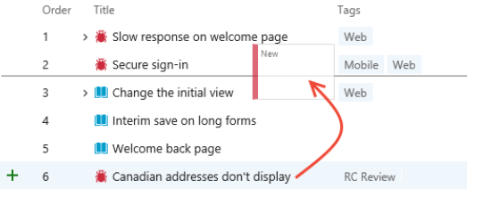

**Collaborate:**

* Collaborate with others through the **Discussion** section of the work item form, using **@mention**s and **#ID** controls to quickly include others in the conversation or link to other work items.
* Create dashboards that track status and trends of work being accomplished
* Set notifications to get alerted when an issue is created or changed.

1. From the web portal, select the icon with your initials or picture, and then select **Notification settings** from the drop-down menu.

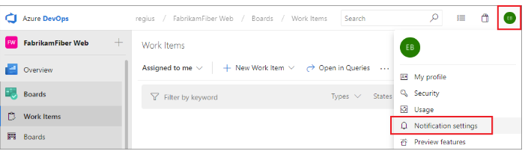**View all subscriptions:**

This view shows all subscriptions that you have created or that have been created by an administrator. Subscriptions let you control what you are notified about. Those notifications you're subscribed to are indicated with the State as **On**.

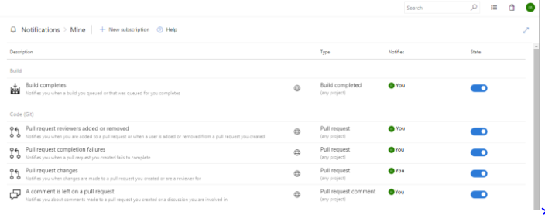

A subscription can be just for you, or if you are a team admin, can be shared by everyone in the team.

**Add a Custom Subscription:**

With custom personal subscriptions, you can define precise criteria for the events you want to receive notifications for. In contrast to a default subscription, which only notifies the users or groups directly associated with an event, a custom subscription can notify you about any event.

1. From your Notifications page, select **New subscription**.

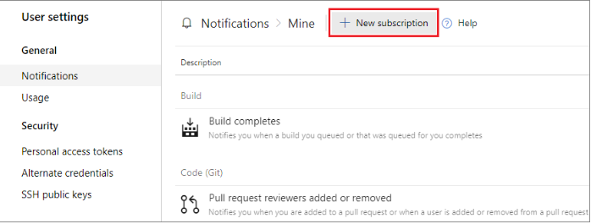

1. Choose the category and template you want to use

Here we choose to get notified when a pull request is created within a specific project.

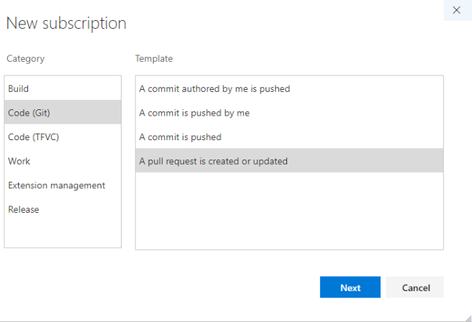

1. Modify the description to help you identify the subscription later. Also choose an email address for notifications to be delivered to. By default, your preferred email address is used. optionally, include one or more fields to further specify the event criteria.

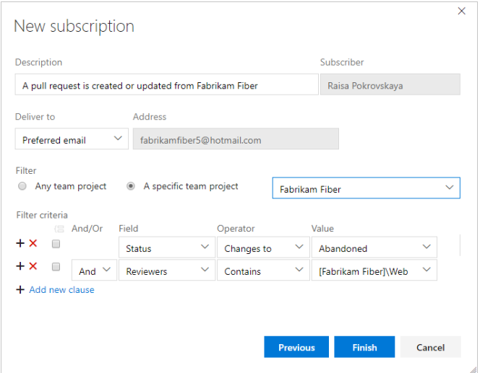

1. Select **Finish** when you're done. The subscription now appears in the list under the category you selected.



**Unsubscribe or opt out of team:**

* You can choose to not receive notifications for certain team subscriptions by opting out of the subscription.
* To unsubscribe from any notification, even one that you've defined, slide the State **On/Off** indicator to the Off position.
* For example, here we turn off the Build completes subscription.

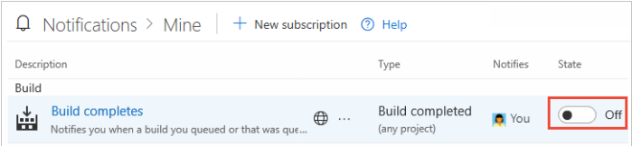

* Select to follow specific issues to get alerted when they are updated.

Get updated when work item is updated

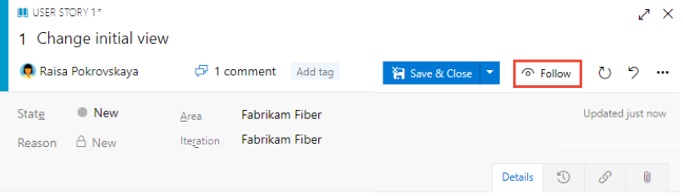

**Work in sprints, implement scrum:**

* Plan sprints by assigning work to current or future sprints.
* Forecast work that can get completed based on effort estimates.
* Determine how much work can be done within a sprint.
* Bulk assign issues and tasks to team members and sprints.

**Assign backlog items to a sprint:**

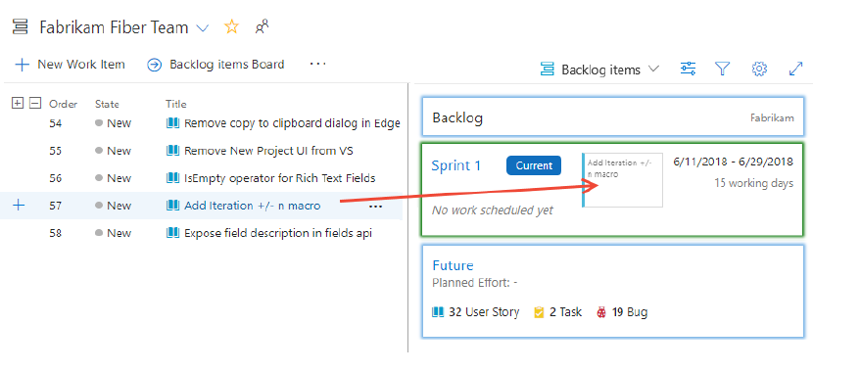

**Work Effectively:**

* Organize work into a hierarchy by grouping issues under epics, and tasks under issues.
* Create queries and quickly triage issues and tasks.
* Create work item templates to help contributors quickly add and define open meaningful issues and tasks.
* Quickly find work items assigned to you or pivot or filter work items based on other criteria, such as work items that you follow, that you're mentioned in, or that you viewed or updated.

